

Practices for Secure Software Report

Table of Contents
Document Revision History 3
Client 3
Instructions 3
Developer 4
1. Algorithm Cipher 4
2. Certificate Generation 4
3. Deploy Cipher 4
4. Secure Communications 4
5. Secondary Testing 4
6. Functional Testing 4
7. Summary 4
8. Industry Standard Best Practices 4

Document Revision History

Version | Date | Author | Comments
1.0 | 10/22/26 | Marisela Galindo

Client



Instructions

Submit this completed practices for secure software report. Replace the bracketed text with the relevant information. You must document your process for writing secure communications and refactoring code that complies with software security testing protocols.

- Respond to the steps outlined below and include your findings.
- Respond using your own words. You may also choose to include images or supporting materials. If you include them, make certain to insert them in all the relevant locations in the document.
- Refer to the Project Two Guidelines and Rubric for more detailed instructions about each section of the template.

Developer
Marisela Galindo

Algorithm Cipher

For this project, I used the SHA-256 hashing algorithm to help verify that data had not been changed. SHA-256 produces a 256-bit hash value based on the information being processed. I chose this algorithm because it is widely used and makes it extremely difficult to find two different inputs that produce the same hash. This makes it useful for checksum verification and checking data integrity.
SHA-256 is a hashing algorithm rather than an encryption cipher, meaning it does not use a key or allow the original information to be decrypted. For secure communication, I would recommend AES-256 because it uses a 256-bit symmetric key to encrypt and decrypt data. Symmetric encryption uses the same secret key for both processes, while asymmetric encryption uses a public and private key pair. Secure random numbers are also important because they help generate unpredictable encryption keys.
Encryption has improved over time as older algorithms, such as DES, have become outdated due to security weaknesses. AES is a more modern and secure option that is widely used today. Combining strong encryption with SHA-256 hashing helps protect both the confidentiality and integrity of information. For Artemis Financial, these security measures are especially important because the application handles sensitive financial information.

Certificate Generation
Insert a screenshot below of the CER file.

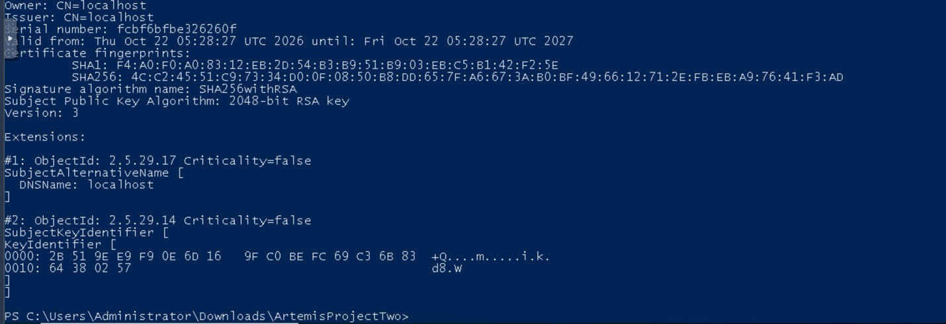

Deploy Cipher
Insert a screenshot below of the checksum verification.

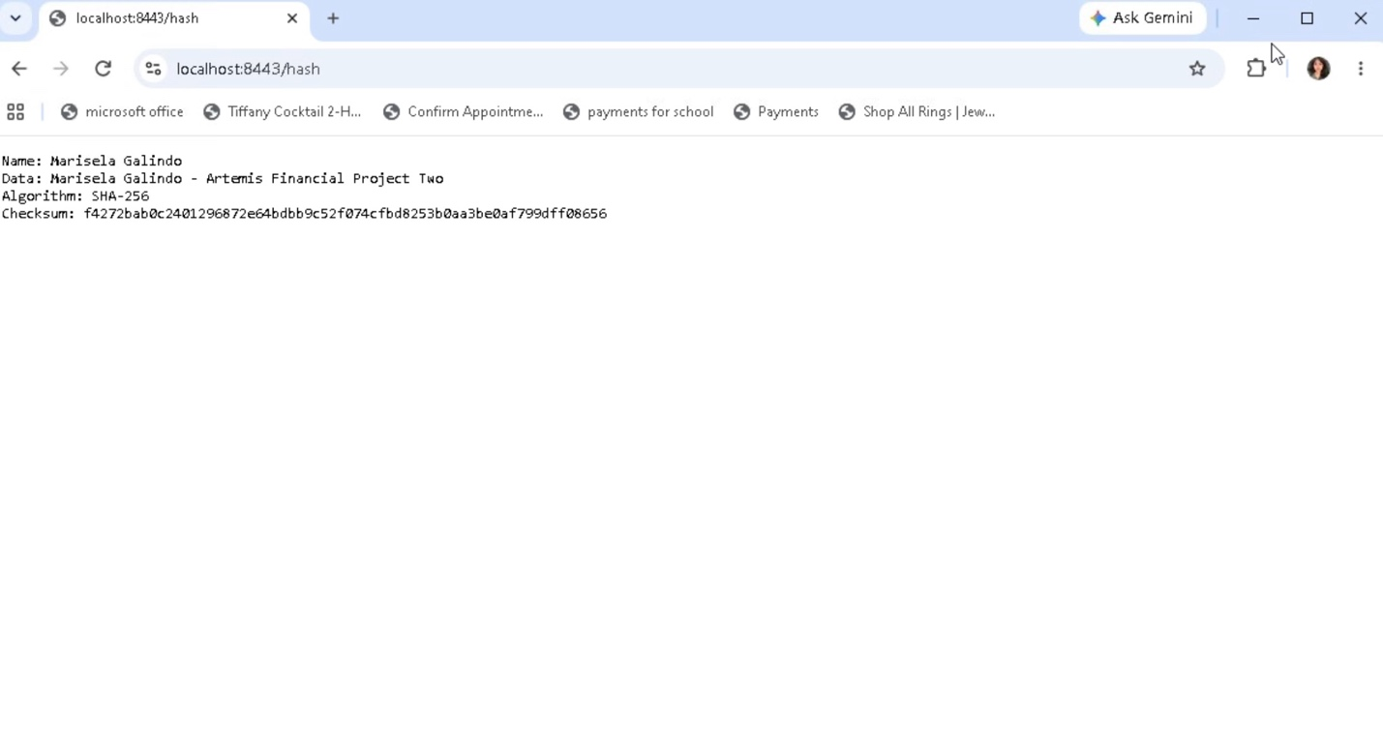

Secure Communications
Insert a screenshot below of the web browser that shows a secure webpage.

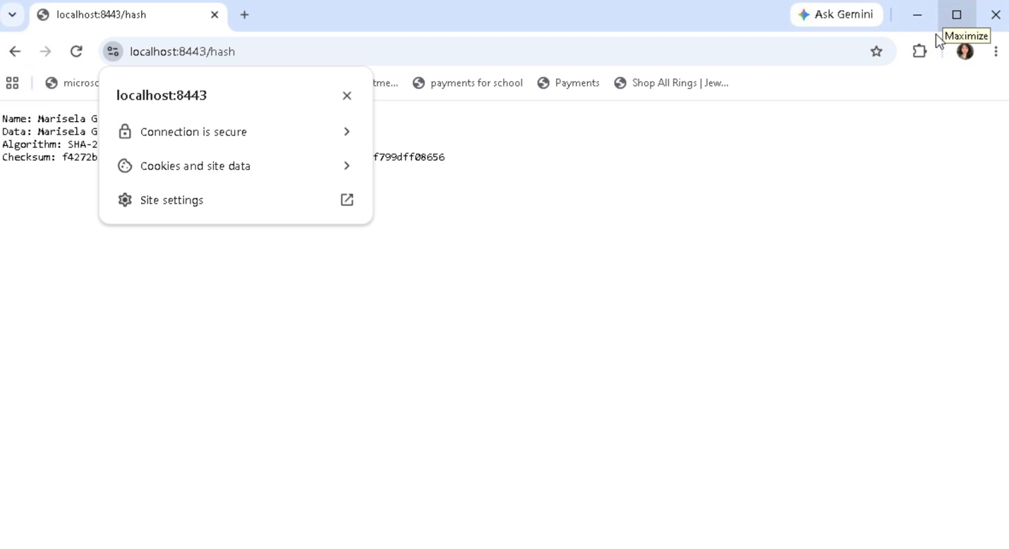

Secondary Testing
Insert screenshots below of the refactored code executed without errors and the dependency-check report.

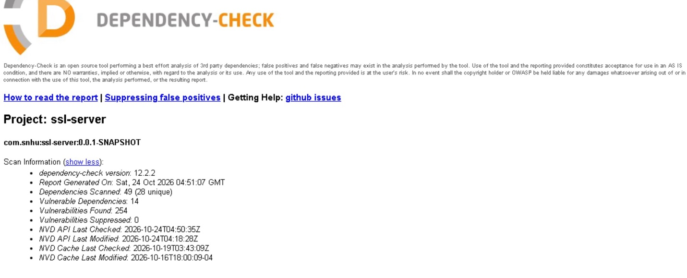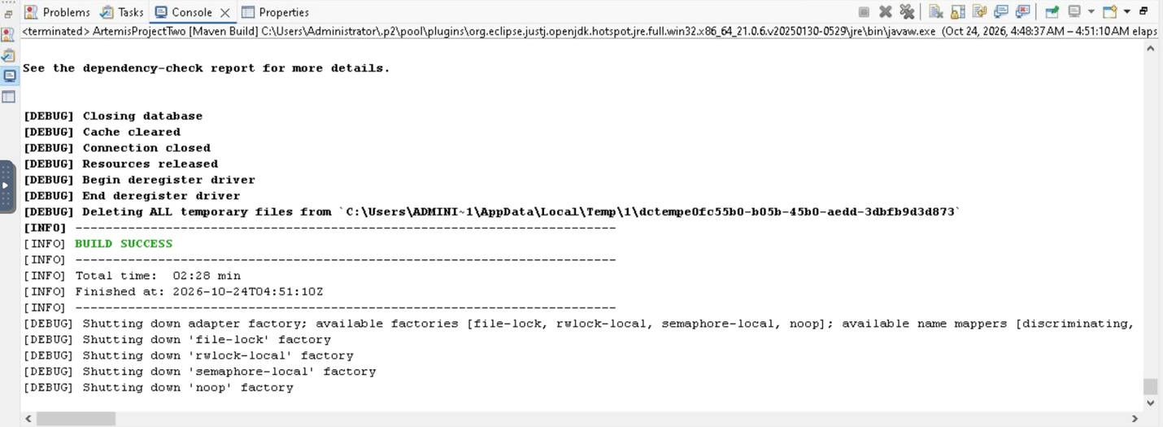

Functional Testing
Insert a screenshot below of the refactored code executed without errors.

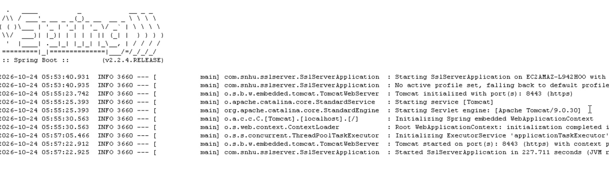

Summary

For Project Two, I updated the Artemis Financial application to improve its security. I used SHA-256 for checksum verification, generated a self-signed certificate, and configured HTTPS to help protect communication between the application and the browser. These changes added extra layers of security by helping verify data integrity and supporting encrypted communication. I also tested the application to make sure it could run successfully after making these updates.
During testing, the application successfully started using HTTPS on port 8443. I also completed an OWASP Dependency-Check scan, which identified 254 potential vulnerabilities across 14 dependencies. Although the scan completed successfully, these findings indicate that some security concerns still need to be reviewed. This project helped me understand how important it is to check for vulnerabilities, test software after making changes, and keep dependencies updated. Regular security testing can help maintain a safer application over time.

Industry Standard Best Practices

During this project, I followed several security best practices to improve the Artemis Financial application. I configured HTTPS, generated a self-signed certificate, and implemented SHA-256 hashing to verify data integrity. These changes help protect sensitive information and reduce the risk of unauthorized changes. I also used OWASP Dependency-Check to identify potential security vulnerabilities in the application’s dependencies. Reviewing these results is important because outdated software components can create security risks even when the application itself runs correctly.
Following industry-standard security practices helps companies protect customer information and maintain trust. For a financial company like Artemis Financial, keeping information secure is especially important. Regularly updating dependencies, reviewing security reports, and testing the application after making changes can help reduce future vulnerabilities. These practices also help prevent security incidents that could affect the company’s reputation and operations.

